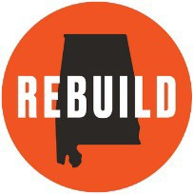
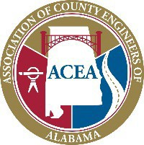
Rebuild Alabama Act Model Bid Advertisement

Advertisement for Bid
County

County is taking sealed bids for labor, equipment, materials, and any incidentals required to complete the work required for the (ENTER BID DESCRIPTION HERE) of the County. This bid is intended to comply with the Rebuild Alabama Act, Act No. 2019-2, as amended, and the Alabama Public Works Law, Alabama Code Title 39, as amended. Bidders shall be required to comply with the provisions of the Rebuild Alabama Act, Act No. 2019-2, as amended, and the Alabama Public Works Law, Alabama Code Title 39, as amended, regardless if the requirement is explicitly detailed in the bid proposal or not.

Sealed bids will be received by the County Commission at
until AM Central Time on
, and then publicly opened as soon thereafter as practicable. Award will bemade at the next regularly scheduled meeting of the County Commission.

Specifications are on file and may be acquired at the County, Alabama, Engineering Department, , , Alabama.
Phone Number:
County Hours of Operation are A.M. to P.M. (Central Time) from through .

County reserves the right to accept or reject all Bids or any portion thereof.

